**Cold Front**

[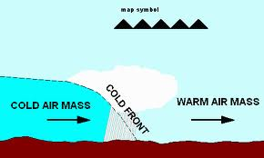](http://www.google.com/imgres?hl=en&safe=strict&sa=X&rls=com.microsoft:en-us&biw=1366&bih=595&tbm=isch&prmd=imvns&tbnid=0HaQ2Y0bAbHNBM:&imgrefurl=http://kidlat.pagasa.dost.gov.ph/genmet/fronts/classification_of_fronts.html&docid=-2CUhlfJeARBKM&imgurl=http://kidlat.pagasa.dost.gov.ph/genmet/fronts/coldfront.gif&w=500&h=300&ei=xudiUMy-D4TY9QT-kYCYAw&zoom=1&iact=hc&vpx=286&vpy=303&dur=140&hovh=174&hovw=290&tx=150&ty=139&sig=112575455708849097768&page=1&tbnh=104&tbnw=174&start=0&ndsp=21&ved=1t:429,r:15,s:0,i:121)

**Warm Front**

[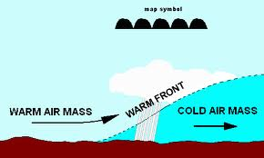](http://www.google.com/imgres?hl=en&safe=strict&sa=X&rls=com.microsoft:en-us&biw=1366&bih=595&tbm=isch&prmd=imvns&tbnid=4LqeC8MqQLz8JM:&imgrefurl=http://kidlat.pagasa.dost.gov.ph/genmet/fronts/classification_of_fronts.html&docid=-2CUhlfJeARBKM&imgurl=http://kidlat.pagasa.dost.gov.ph/genmet/fronts/warmfront.gif&w=500&h=300&ei=XediUKfzLoSm9AT5qoCgBw&zoom=1&iact=hc&vpx=417&vpy=160&dur=2000&hovh=174&hovw=290&tx=184&ty=107&sig=112575455708849097768&page=1&tbnh=101&tbnw=169&start=0&ndsp=21&ved=1t:429,r:16,s:0,i:124)

**Stationary Front**

[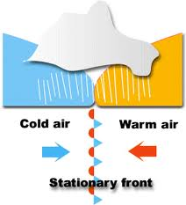](http://www.google.com/imgres?hl=en&safe=strict&sa=X&rls=com.microsoft:en-us&biw=1366&bih=595&tbm=isch&prmd=imvns&tbnid=XmO-9gLZUOazqM:&imgrefurl=http://library.thinkquest.org/C0125863/weather/front.html&docid=j78fMHpCk9N4HM&imgurl=http://library.thinkquest.org/C0125863/weather/image/front_stationary_en.gif&w=265&h=292&ei=guhiUN62OYmi8ATamIDgBw&zoom=1&iact=hc&vpx=300&vpy=2&dur=1343&hovh=233&hovw=212&tx=113&ty=64&sig=112575455708849097768&page=1&tbnh=127&tbnw=115&start=0&ndsp=21&ved=1t:429,r:1,s:0,i:77)